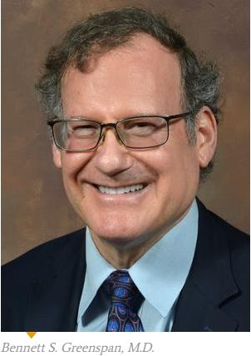

Bennett S. Greenspan
MD, MS, FACNM, FACR, FSNMMI, FAAPM

Bennett S. Greenspan just completed his term as President of SNMMI in June, 2018. He graduated from the University of Illinois School of Medicine. He is board-certified in radiology and nuclear medicine by ABR and ABNM. He received the MS in Medical Physics from UCLA. Dr. Greenspan has been involved in research, education, and national service and leadership for many years. He is a national and international leader in nuclear medicine and is known as an expert in quality and safety in Nuclear Medicine and Radiology. He has served on numerous committees of SNMMI and AAPM. He has given over 75 invited presentations on nuclear medicine regionally, nationally and internationally, and 19 presentations as a Visiting Professor. His research and scholarly interests include radionuclide therapy in oncology and low dose radiation. He currently chairs a committee within SNMMI on LNT.

