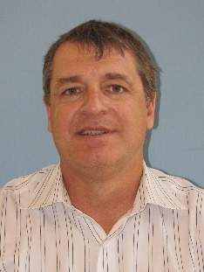

ANTONY M. HOOKER
BBiotech(Hons), PhD, FARPS, MACPSEM

Tony is Principal Radiation Advisor, Radiation Health, South Australian Environment Protection Authority and sits on Australia’s Radiation Health Committee, which advises on matters relating to radiation protection, including formulating draft national policies, codes and standards. He holds academic positions at the University of Adelaide and Flinders University and is a Fellow and Past-President of the Australasian Radiation Protection Society and a Member of the Australasian College of Physical Scientists and Engineers in Medicine. Tony has been involved in mutation and cancer research since 1995, including low dose radiation research within the US DOE Low Dose Radiation Research Program. He has published on non-linear responses after x-irradiation and on the need to change from the current LNT radiation regulatory policy. Tony is currently involved in a number of radiation research projects and is establishing a Centre for Radiation Research, Education and Innovation in Adelaide to meet the future demands for radiation professionals in Australia.

