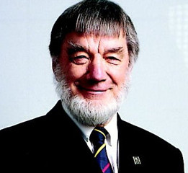
BRYAN LEYLAND
Power System Design Engineer, New Zealand

Bryan Leyland is a power system design engineer and consultant on hydro-electric projects throughout Asia and Africa. He has studied safety issues of dams and found nuclear to be a lot safer. He has studied low dose radiation topics across the nuclear power industry with Emeritus Professor of Physics, Wade Allison at Oxford University in the UK. He has studied the topic of man-made global warming. He is a member of the Board of Advisors for Environmentalists for Nuclear – USA.

