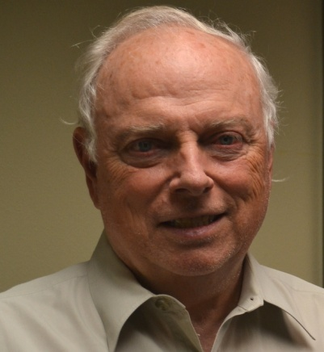
JOHN A. SHANAHAN
Civil Engineer, USA

John A. Shanahan is President of Environmentalists for Nuclear – USA. He holds a Dr. Eng. (Engineering) degree from Ruhr University Bochum in Germany and Bachelor’s and Master’s in Civil Engineering from U. of Notre Dame. From 1969 to 1987, he worked in research, design and licensing for commercial nuclear power plants in the United States and Switzerland. Since 2010, he has been working full time to contribute to global public education for nuclear power, nuclear medicine and nuclear science. The website is: efn-usa.org. EFN-USA has a fifty member International Board of Advisors, over 700 contributing authors, and connections in 120 countries.

