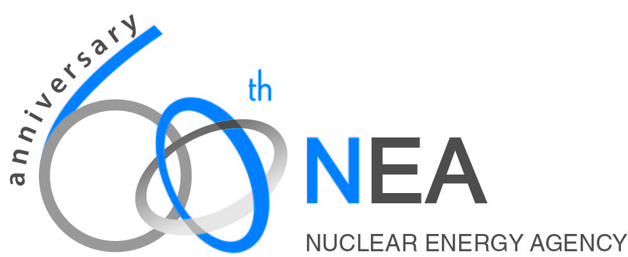
Science and Values in Radiological Protection

Our scientific understanding of how ionising radiation interactions with living tissues has improved significantly over the past 20 years, notably through epidemiological studies, and the development of new tools for molecular epidemiological studies and for cellular radiobiology. In spite of extensive efforts, there is little scientific understanding of whether or not doses below the 50 – 100 mSv range bring stochastic risks. But while radiological protection decisions are informed by scientific knowledge and understanding, radiological protection decisions are in fact judgements driven by social values. So while we need to know scientifically whether there is a dose threshold below-which there is no risk, and we need to know how risk to populations and individuals is related to radiation dose, such knowledge will not answer the question of how radiological exposures should be identified and regulated to be as low as reasonably achievable. Reasonable is a judgement, decided by the decider with input from science, understanding prevailing circumstances, and considering stakeholder concerns. This paper will discuss the state-of-the-art scientific knowledge and understanding of low-dose effects, and will explore some possible regulatory approaches that could be employed if, at some point, we know whether or not low-dose effects exist.

Background
What does “Safe” mean? Regulators strive to develop and enforce regulations that will keep the public, workers and the environment safe. Operators strive to follow regulations and to keep all public and worker exposures As Low As Reasonably Achievable - to keep everything safe. But does safe mean zero risk? How do regulators, operators and the public understand the concept of “Safe”?
The Oxford English dictionary defines Safe as: protected from, or not exposed to danger or risk; not likely to be harmed or lost; not likely to cause or lead to harm or injury; not involving danger or risk.
The Merriam-Webster American English dictionary defines Safe as: free from harm or risk; secure from threat of danger, harm, or loss; affording safety or security from danger, risk, or difficulty; harmless.
But safe is an inherently judgemental view: “protected from”, “not likely to”, “secure from threat”, etc. Some people think it is safe to parachute out of a plane, others think that is crazy. A person’s decision that something is safe or not is that person’s personal judgement, based on their personal, social, political, economic, etc. values.
ALARA and Optimisation are the processes used to achieve the best protection under the prevailing circumstances. The “best” choice is also a judgement, an opinion based on state-of-the-art science and thorough understanding of the prevailing circumstances.
LNT and Thresholds
Our scientific understanding of how ionising radiation interacts with living tissues has improved significantly over the past 20 years. Yet today there is not enough scientific understanding to definitively say whether or not doses below the 50 – 100 mSv range bring stochastic risks. At these doses we do not know whether radiological protection standards and regulations are too strict, just right, or not strict enough. Should LNT continue as a basis for radiological risk assessment? Is there a threshold below which there is no risk – or even positive benefit.
LNT Cons: LNT suggests that there is risk from any dose, causing two major problems. First, this has caused and continues to cause people to fear radiation exposure. Second, public fear causes the spending of excessive resources to reduce doses to well below regulatory criteria. ALARA is often taken as minimisation, “As Close To Zero As Possible (ACTZAP).
LNT Pros: LNT is a convenient mathematical construct that allows us to compare apples and oranges, that is, exposures can be mathematically manipulated into a single quantity, effective dose, representing risk. This makes dosimetry for protection purposes possible.
What if there is no LNT: What function would replace the LNT straight line in the 0 to 5 rem range (0 to 50 mSv), some sort of curve? If a curve, a given dose where the curve was somewhat horizontal would be small risk; the same dose where the curve was somewhat vertical would be larger risk. A nuclear worker receiving 500 mrem from a CT scan might then have higher risk from the next 100 mrem received at work. This could imply the need to monitor in some fashion manage ALL types of exposure – occupational, medical, radon, terrestrial, airline flight exposure, etc.
Threshold Pros: Say that scientific proof emerges that below some threshold dose there is no risk, or there are benefits. This could reduce public fear, and ease regulations on: operational gaseous and liquid effluents; decommissioning waste; site clean-up criteria; management requirements for NORM industry materials; etc.
Threshold Cons: The latest reputable epidemiological studies suggest that doses less than 5 rem carry a small but statistically significant risk (Little et al., Lancet Haematol 2018) such that any threshold would be no higher than a few rem of total exposure above background: lifetime exposure. This has two implications. First, it could be assumed that there is a dose below which there is no risk, there would be a certain moral and ethical need to at least try to keep everyone below this threshold. However, in that this is a lifetime cumulative dose, it would need to include all non-background exposures: occupational, medical, air flight, NORM, etc. (accounting for background variations). This would imply that currently non-regulated exposures would at least need to be registered, if not regulated, to keep individuals under the no-risk threshold. Second, taking such currently non-regulated sources into account would mean that a threshold level of a few rem would easily be reached by workers, and even by members of the public. This would most likely increase pressure to at the very least maintain regulatory control over emissions, and would perhaps push for NPP shutdowns to assure the avoidance of accidents.
Conclusions
This discussion began with the judgemental nature of identifying the best protection choices under prevailing circumstances: i.e. Safe; ALARA; Optimum. The concerns discussed with having or not a threshold, and with using or not LNT, suggest that ALARA and Optimisation have been interpreted in very conservative fashions, causing public fear of radiation (mostly from NPPs), greatly affecting the costs of all phases of NPP life-cycles. If decisions are only informed by science but driven by judgement and values, if science cannot tell us what level of risk is “safe”, and if discarding LNT and taking on a threshold seem to cause significant issues, perhaps the issue to discuss is the conservative nature of regulatory and operational judgements. Perhaps new approaches to risk communication are needed. Perhaps science should be allowed to do its thing and continue to ask questions: does LNT represent risks too conservatively, to liberally, or just right?; can hormesis really be generalised to all exposures and individuals?; is there a safe/unsafe boundary? We have lots to discuss!

